ISO 20022

**Money Market Statistical Reporting (MMSR)**

Message Definition Report - Part 1

# Urgent maintenance 2017 – Approved by the Securities SEG on 29 May 2017

Edition May 2017

Table of contents

1. Introduction 4

1.1 Terms and definitions 4

1.2 Glossary 4

1.3 Document Scope and Objectives 5

1.4 References 5

2. Scope and Functionality 6

2.1 Background 6

2.2 Scope 6

2.3 Groups of MessageDefinitions and Functionality 6

3. BusinessRoles and Participants 7

4. BusinessProcess Description 9

4.1 BusinessProcess Diagram 9

5. Description of BusinessActivities 11

5.1 BusinessProcess – Data Collection and Status Advice 12

5.1.1 Direct reporting to ECB scenario 12

5.1.2 Indirect reporting through the NCB to the ECB scenario 13

5.2 BusinessActivities 13

6. BusinessTransactions 15

6.1 Overview of the Money Market Statistical Reporting flows 15

6.2 Secured Market Statistical Reporting BusinessTransaction 17

6.2.1 Direct reporting to the ECB scenario 17

6.2.2 Indirect reporting through the NCB to the ECB scenario 17

6.3 Unsecured Market Statistical Reporting BusinessTransaction 18

6.3.1 Direct reporting to the ECB scenario 18

6.3.2 Indirect reporting through the NCB to the ECB scenario 18

6.4 Foreign Exchange Swaps Statistical Reporting BusinessTransaction 19

6.4.1 Direct reporting to the ECB scenario 19

6.4.2 Indirect reporting through the NCB to the ECB scenario 19

6.5 Overnight Index Swaps Statistical Reporting BusinessTransaction 20

6.5.1 Direct reporting to the ECB scenario 20

6.5.2 Indirect reporting through the NCB to the ECB scenario 20

7. Examples 21

7.1 MMSR Secured Market Report - auth.012.001.02 21

7.2 MMSR Unsecured Market Report - auth.013.001.02 23

7.3 MMSR Foreign Exchange Swaps Report - auth.014.001.02 24

7.4 MMSR Overnight Index Swaps Report - auth.015.001.02 25

8. Revision Record 26

**Preliminary note:**

The Message Definition Report (MDR) is made of three parts:

* **MDR - Part 1** describes the contextual background required to understand the functionality of the proposed message set. Part 1 is produced by the submitting organisation that developed or maintained the message set in line with a MDR Part1 template provided by the ISO 20022 Registration Authority (RA) on [www.iso20022.org](http://www.iso20022.org)
* **MDR – Part 2** is the detailed description of each MessageDefinition of the message set. Part 2 is produced by the RA using the model developed by the submitting organisation.
* **MDR – Part 3** is an extract of the ISO 20022 Business Model describing the business concepts used in the message set. Part 3 is an Excel document produced by the RA.

# Introduction

## Terms and definitions

The following terms are reserved words defined in ISO 20022 – Part 1. When used in this document, they will follow the UpperCamelCase notation.

|  |  |
| --- | --- |
| Term | Definition |
| BusinessRole | functional role played by a business actor in a particular BusinessProcess or BusinessTransaction |
| Participant | involvement of a BusinessRole in a BusinessTransaction |
| BusinessProcess | unrealized definition of the business activities undertaken by BusinessRoles within a BusinessArea whereby each BusinessProcess fulfils one type of business activity and whereby a BusinessProcess may include and extend other BusinessProcesses |
| BusinessTransaction | particular solution that meets the communication requirements and the interaction requirements of a particular BusinessProcess and BusinessArea |
| MessageDefinition | formal description of the structure of a MessageInstance |

## Glossary

**Acronyms**

|  |  |
| --- | --- |
| Acronym | Definition |
| ECB | European Central Bank |
| NCB | National Central Bank |
| RA | Reporting Agent |
|  |  |
|  |  |

**Abbreviations**

|  |  |
| --- | --- |
| Abbreviation | Definition |
| MMSR | Money Market Statistical Reporting |
|  |  |
|  |  |

## Document Scope and Objectives

This document is the first part of the ISO 20022 Message Definition Report (MDR) that describes the BusinessTransactions and underlying message set. For the sake of completeness, the document may also describe BusinessActivities that are not in the scope of the project.

This document sets:

* The BusinessProcess scope (business processes addressed or impacted by the project)
* The BusinessRoles involved in these BusinessProcesses

The main objectives of this document are:

* To explain what BusinessProcesses and BusinessActivities these MessageDefinitions have addressed
* To give a high level description of BusinessProcesses and the associated BusinessRoles
* To document the BusinessTransactions and their Participants (sequence diagrams)
* To list the MessageDefinitions

## References

| Document | Version | Date | Author |
| --- | --- | --- | --- |
| ISO 20022 Business Justification – Money Market Statistical Reporting |  | 2015-06-26 | ECB |
| Reporting instructions for the electronic transmission of Money Market Statistics |  |  | ECB |
| REGULATION (EU) No 1333/2014 OF THE EUROPEAN CENTRAL BANK of 26 November 2014 concerning statistics on the money markets (ECB/2014/48) |  | 2014-11-26 | ECB |
| ISO 20022 Change Request – Urgent Unscheduled – auth.012-auth.015 |  | 2016-11-03 | ECB |
|  |  |  |  |

# Scope and Functionality

## Background

This Message Definition Report covers a set of five (5) ISO 20022 MessageDefinitions developed by the European Central Bank in close collaboration with Banque de France, Banco de España and Deutsche Bundesbank and approved by the Securities Standards Evaluation Group (SEG) on 25 January 2016. These messages are specifically designed to support the regulatory requirement as defined in the Money Market Statistical Reporting (MMSR), which has the following objectives:

1. achieve a better understanding and timely surveillance of the functioning of money markets in general and of banks’ funding in different segments in particular;
2. provide better and timelier information on the monetary policy transmission mechanism as well as to provide improved information on market expectation on the future trajectory of policy rates;
3. provide more information to market participants on the function of the money markets.

In 2017, four of the MessageDefinitions were reviewed to harmonise the use of the message set by the ECB and the Bank of England for Money Market Statistical Reporting and Sterling Money Market Daily (SMMD) respectively. The new version of these MessageDefinitions was approved by the ISO 20022 Securities SEG on 29 May 2017.

## Scope

In the context of the new Money Market Statistical Reporting (MMSR) regulation, from 1 April 2016 the European System of Central Bank (ESCB) started collecting high frequency transaction level data from reporting agents*[1]* on their money market activities in the secured, unsecured, FX Swaps and Euro OIS market segment.*[2]* The US Federal Reserve had launched a similar monitoring (put into production as of 1 April 2014), and some non-euro area EU NCBs are also interested to make a similar endeavour.

Taking into account the large data volumes and the high frequency of the data collection, the aim is to establish a full automation of the data flows between the reporting credit institutions, National Central Banks (NCBs), where applicable, and the European Central Bank (ECB). In this regard it is intended to prepare a full standardisation of the underlying taxonomy and data transmission format based on ISO standards.

## Groups of MessageDefinitions and Functionality

Each reporting agent has to report on a daily basis, all transactions which are denominated in euro for four specific Money Market areas. Therefore, the Money Market Statistical Reporting consists of a set of four (4) reporting MessageDefinitions, one for each segment of the market. In this respect:

* The MMSR secured market report MessageDefinition (auth.012), provides the details on all secured market transactions;
* The MMSR unsecured market report MessageDefinition (auth.013), provides the details on all unsecured market transactions;
* The MMSR Foreign Exchange Swaps report MessageDefinition (auth.014), provides the details on all Foreign Exchange Swaps transactions;
* The MMSR Overnight Index Swaps report MessageDefinition (auth.015), provides the details on all Overnight Index Swaps transactions.

In response to those reports and to support a fully automated process, a status advice message (auth.028) is added to respond to the reporting agent on the status of the submitted reports and/or transactions. This message is designed to provide the status on the full report and/or on individual submitted transactions, together with the details of the MMSR validation rules which have been violated in the submitted report and/or transaction.

**Note that these MessageDefinitions are intended for use with a “restricted” version[3] of the ISO 20022 Business Application Header (head.001). The schema and more information about the Business Application Header (BAH) can be found on** [**www.iso20022.org**](http://www.iso20022.org/bah.page) **.**

# BusinessRoles and Participants

A BusinessRole represents an entity (or a class of entities) of the real world, physical or legal, a person, a group of persons, a corporation. Examples of BusinessRoles: “Financial Institution”, “ACH”, “CSD”.

A Participant is a functional role performed by a BusinessRole in a particular BusinessProcess or BusinessTransaction: for example the “user” of a system, “debtor”, “creditor”, “investor” etc.

The relationship between BusinessRoles and Participants is many-to-many. One BusinessRole (that is, a person) can be involved as different Participants at different moments in time or at the same time: "user", "debtor”, "creditor", "investor", etc. Different BusinessRoles can be involved as the same Participant.

In the context of MMSR, the high-level BusinessRoles and typical Participants can be represented as follows.

NCBs

**Competent**

**Authority**

ECB

Non-financial

Corporations

**Reporting**

**Agent**

General

Government

MFIs

Pension Funds

OFIs

Insurance

Corporations

| **Participants and BusinessRoles definitions** | |
| --- | --- |
| **Description** | **Definition** |
| Participants | |
| Reporting Agent | Party that is required to provide daily reports on money market statistical reporting, as specified in the Regulation (EU) No 1333/2014 of the European Central Bank (ECB/2014/48). Reporting agents are a selected subset of euro area monetary financial institutions (MFIs), including all their Union and European Free Trade Association (EFTA)-located branches. ‘Monetary financial institution’ (MFI) has the same meaning as defined in Article 1 of Regulation (EU) No 1071/2013 of the European Central Bank (ECB/2013/33). |
| Counterparties of Reporting Agent | Reporting agents have to report money market transactions conducted by the reporting agent with other MFIs, other financial intermediaries (OFIs), insurance corporations, pension funds, central banks (excluding transactions related to the Eurosystem tender operations and marginal lending facilities), the general government as well as transactions with non-financial corporations classified as ‘wholesale’ pursuant to the Basel III liquidity coverage ratio (LCR) framework, as specified in the Regulation (EU) No 1333/2014 of the European Central Bank (ECB/2014/48). |
| Competent Authority | Party which collects the statistical data on money market statistical reporting. |
| BusinessRoles | |
| MFI | Monetary Financial Institution has the same meaning as defined in Article 1 of Regulation (EU) No 1071/2013 of the European Central Bank (ECB/2013/33) and shall be read to include all of the MFI's European Union and EFTA-located branches, unless explicitly provided otherwise in any provision of the Regulation. |
| OFI | Other financial intermediaries except insurance corporations and pension funds as set out in the revised European System of Accounts (hereinafter the ‘ESA 2010’) laid down by Regulation (EU) No 549/2013 of the European Parliament and of the Council. |
| Insurance Corporations | All financial corporations and quasi-corporations which are principally engaged in financial intermediation as a consequence of the pooling of risks mainly in the form of direct insurance or reinsurance as set out in the ESA 2010. |
| Pension Funds | All financial corporations and quasi-corporations which are principally engaged in financial intermediation as the consequence of the pooling of social risks and needs of the insured persons (social insurance) as set out in the ESA 2010. |
| Non-financial Corporations | Sector of non-financial corporations as set out in the ESA 2010. |
| General Government | The institutional units which are non-market producers whose output is intended for individual and collective consumption and are financed by compulsory payments made by units belonging to other sectors, and institutional units principally engaged in the redistribution of national income and wealth as set out in the ESA 2010. |
| ECB | The European Central Bank. |
| NCB | National Central Bank(s)’ or ‘NCB(s)’ are the national central banks of Union Member States. |

|  |  |  |  |
| --- | --- | --- | --- |
|  | **BusinessRoles/Participants Matrix Table** | | |
| Participants  BusinessRoles | Reporting Agent | Counterparties of Reporting Agent | Competent Authority |
| MFI | X | X |  |
| OFI |  | X |  |
| Insurance Corporations |  | X |  |
| Pension Funds |  | X |  |
| Non-financial Corporations |  | X |  |
| General Government |  | X |  |
| Central Banks |  | X |  |
| ECB |  | X | X |
| NCB |  | X | X |

# BusinessProcess Description

## BusinessProcess Diagram

This diagram pictures the high level BusinessProcesses covered by this project. The aim of the below is to describe the high-level scope of the project, not to be exhaustive.



Money market statistical reporting process:

* Definition: Reporting agents are required to report to the NCB of the Member State where they are resident or, alternatively, to the ECB daily statistical information relating to money market instruments. Reporting will include all transactions relating to money market instruments booked in their Union and EFTA-located branches.   
  The qualifying principle is the location where the transactions are booked (at the reporting agent level, in all its branches located in the Union and in the EFTA) and not where the transactions are originated or executed.
* Trigger: Each reporting agent must provide a daily statistical report per segment. The report may be an empty report, when no transactions in the scope of the Regulation have been processed. When an NCB receives the report from the reporting agent, it must forward it to the ECB. The reporting can also involve the transmission of multiple files per segment per day per reporting agent where this is agreed with the respective NCB.
* Pre-conditions: All reporting agents have to provide one report per money market segment once per day. Further reporting agents which might be added to the set of reporting agents based on Article 2(6) of Regulation (EU) No 1333/2014 of the European Central Bank (ECB/2014/48), either have to provide one report per money market segment once per day, once a week, or once a month, The reporting agent has to provide one report per money market segment, independent of whether it processed a transaction in the scope of the Regulation.
* Post-conditions: The ECB and/or the NCBs have received the daily reporting.
* Role: Reporting Agent, NCBs or ECB.

Secured market process:

* Definition: The secured market segment is covering the daily repurchase agreement transactions (borrowing and lending) denominated in euro with a maturity up to and including one year (defined as transactions with a maturity date of not more than 397 days after the settlement date) conducted by the reporting agent with other MFIs, OFIs, insurance corporations, pension funds, general government or central banks (excluding transactions related to Eurosystem tender operations and marginal lending facilities) as well as with non-financial corporations classified as ‘wholesale’ according to the Basel III LCR framework.

This is a sub-process of the global reporting money market statistical reporting process.

Unsecured market process:

* Definition: The unsecured market segment is covering the daily unsecured transactions especially:
  1. all borrowing denominated in euro with a maturity of up to and including one year (defined as transactions with a maturity date of not more than 397 days after the settlement date) from other MFIs, OFIs, insurance corporations, pension funds, general government or central banks as well as from non-financial corporations classified as ‘wholesale’ according to the Basel III LCR framework using the instruments defined in the Regulation covering in particular unsecured deposits, call accounts and the issuance of fixed-rate or variable-rate short-term debt securities (defined as transactions with a maturity date of not more than 397 days after the settlement date);
  2. all lending denominated in euro to other credit institutions with a maturity of up to and including one year (defined as transactions with a maturity date of not more than 397 days after the settlement date) via unsecured deposits or call accounts, or via the purchase from the issuing credit institutions of fixed-rate or variable-rate short-term debt securities with an initial maturity of up to and including one year (defined as transactions with a maturity date of not more than 397 days after the settlement date).

This is a sub-process of the global reporting money market statistical reporting process.

Foreign exchange swaps market process

* Definition: The foreign exchange swaps market segment is covering the daily foreign exchange swaps (FX swaps) transactions with a maturity of up to and including one year (defined as transactions with a maturity date of not more than 397 days after the settlement date) in which euro are bought/sold on a near-term value date against a foreign currency with an agreement to re-sell the purchased currency on a forward, pre-agreed maturity date, conducted by the reporting agent with other MFIs, OFIs, insurance corporations, pension funds, general government or central banks (excluding transactions related to Eurosystem tender operations) as well as with non-financial corporations classified as ‘wholesale’ according to the Basel III LCR framework.

This is a sub-process of the global reporting money market statistical reporting process.

Overnight index swaps market process

* Definition: The overnight index swaps market segment is covering the daily euro overnight index swaps (OIS) transactions denominated in euro of any maturity and conducted with other MFIs, OFIs, insurance corporations, pension funds, general government or central banks as well as with non-financial corporations classified as ‘wholesale’ according to the Basel III LCR framework.

This is a sub-process of the global reporting money market statistical reporting process.

# Description of BusinessActivities

This section presents the different BusinessActivities within each BusinessProcess. BusinessActivities of a process are described in swim lane diagrams and are referred in this document as activity diagrams.

The development of an activity diagram is part of the ISO 20022 modelling process and allows capturing the requirements.

The activity diagram provides a zoom-in on the BusinessActivities taking place during each of the BusinessProcesses described in Section 4. It also shows the BusinessActivities that are triggered when another BusinessActivity has a negative result.

What is the activity diagram about?

* It is a diagram representing the ‘common lifecycle’ of a BusinessProcess
* A start point ⚫ shows where the lifecycle of the BusinessProcess commences and the end points show End point where the lifecycle may possibly end
* A lozenge means that a choice between several actions can be made
* A bar means that several actions are initiated in parallel
* The flow of activities between the involved Participants (parties)
* BusinessActivities may result in different actions, that is, information is conveyed from one party to another party.

Both in-scope and out-of-scope activities are included, with a different level of details. There are no information requirements for out-of-scope activities, except that they should be clearly identified in the diagram.

Activity diagrams are always accompanied with a text describing the BusinessActivities and their interactions.

## BusinessProcess – Data Collection and Status Advice

### Direct reporting to ECB scenario



### Indirect reporting through the NCB to the ECB scenario



## BusinessActivities

| **Descriptions of the *BusinessActivities*** | |
| --- | --- |
|  | **Initiator** |
| **Process Transaction:** the reporting agent processes a transaction, which is in the scope of the regulation. | **Reporting Agent** |
| **Record Transaction For Reporting:** the reporting agent records the transaction that will be reported. | **Reporting Agent** |
| **Release MMSR statistics report:** The reporting agent prepares the MMSR report, based on the transactions recorded during the day, and forwards it to the NCB or directly to the ECB (when the NCB has not requested to process the MMSR data itself). | **Reporting Agent** |
| **Validate MMSR statistics report:** The NCB/ECB checks the report received by applying file format checks and by checking the report against the validation rules as defined in the specifications. When the validation against the rules fails, the errors are reported back in the status advice sent back to the reporting agent or to the NCB which will send it to the reporting agent. | **NCB / ECB** |
| **Update MMSR statistics repository**: The NCB/ECB will update the statistical repository with all of the transactions which have been successfully reported by the reporting agent. | **NCB / ECB** |
| **Forward MMSR statistics report:** The NCB forwards the MMSR statistics report to the ECB. | **NCB** |
| **Generate status advice:** The NCB and the ECB generate the status advice for the statistics report received. A status may be provided for the whole report, for individual transactions, and will provide details of the validation rules which have not passed successfully if any. | **ECB / NCB** |
| **Process status:** The reporting agent receives the status advice and addresses the issues as reported in the status advice. | **Reporting Agent** |
| **Correct errors**: The reporting agent corrects the transaction for which an error has been raised, and reports again the same transaction with the required corrections, with an amendment/correction status indication in a subsequent daily report. | **Reporting Agent** |

# BusinessTransactions

This section describes the message flows based on the activity diagrams documented above. It shows the typical exchanges of information in the context of a BusinessTransaction.

## Overview of the Money Market Statistical Reporting flows

The below diagram presents the generic business transaction for the reporting of the Money Market Statistical Reporting flow:



In response to the four reports submitted on a daily basis, the NCB / ECB send back a status advice to report on the successful submission of the report or to provide details on the validation rules which have been violated in the report.



## Secured Market Statistical Reporting BusinessTransaction

### Direct reporting to the ECB scenario

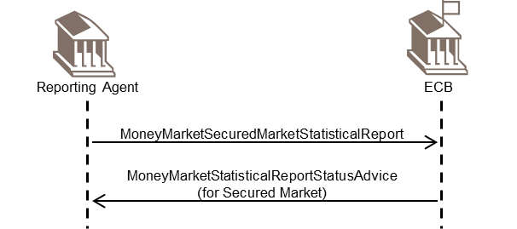

### Indirect reporting through the NCB to the ECB scenario

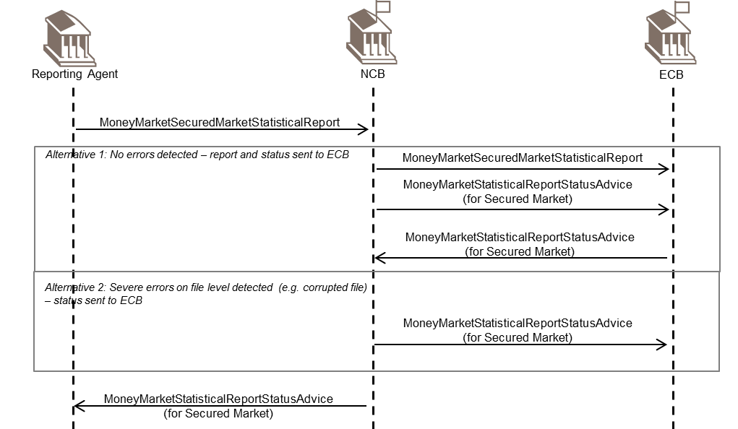

## Unsecured Market Statistical Reporting BusinessTransaction

### Direct reporting to the ECB scenario

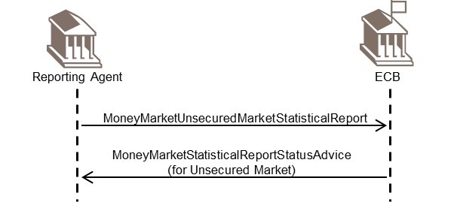

### Indirect reporting through the NCB to the ECB scenario

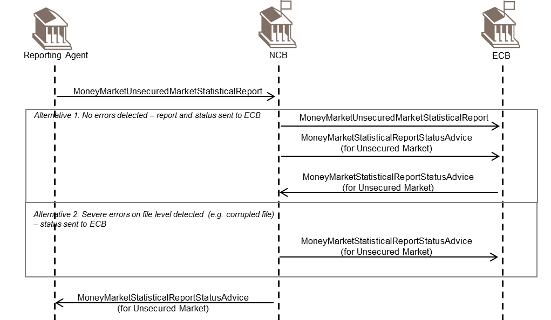

## Foreign Exchange Swaps Statistical Reporting BusinessTransaction

### Direct reporting to the ECB scenario

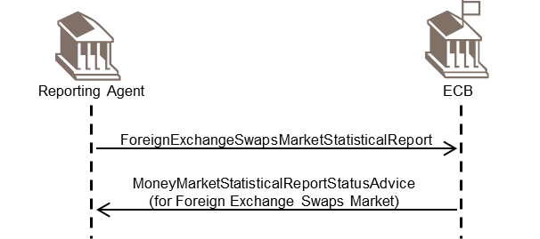

### Indirect reporting through the NCB to the ECB scenario

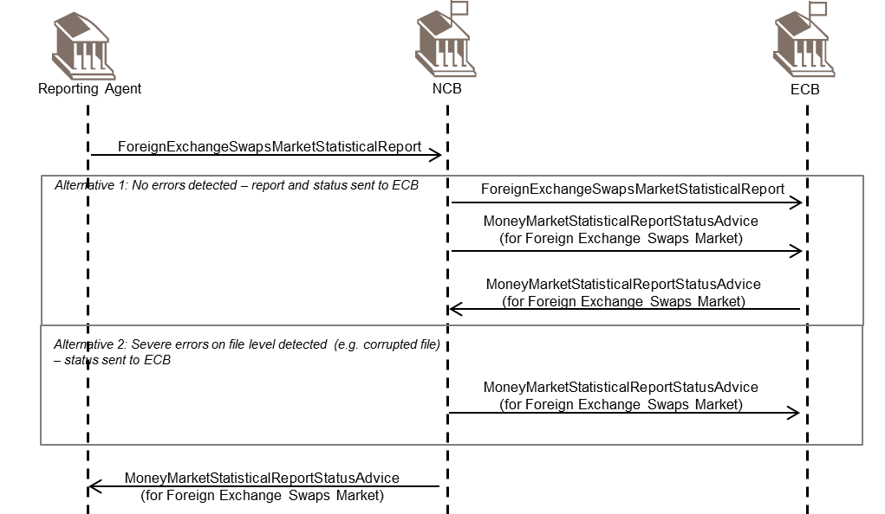

## Overnight Index Swaps Statistical Reporting BusinessTransaction

### Direct reporting to the ECB scenario

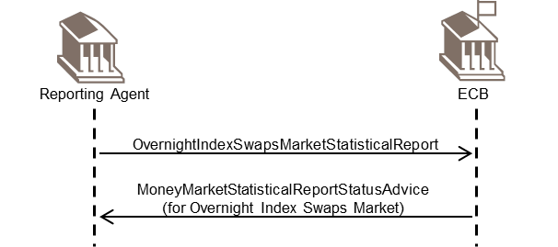

### Indirect reporting through the NCB to the ECB scenario

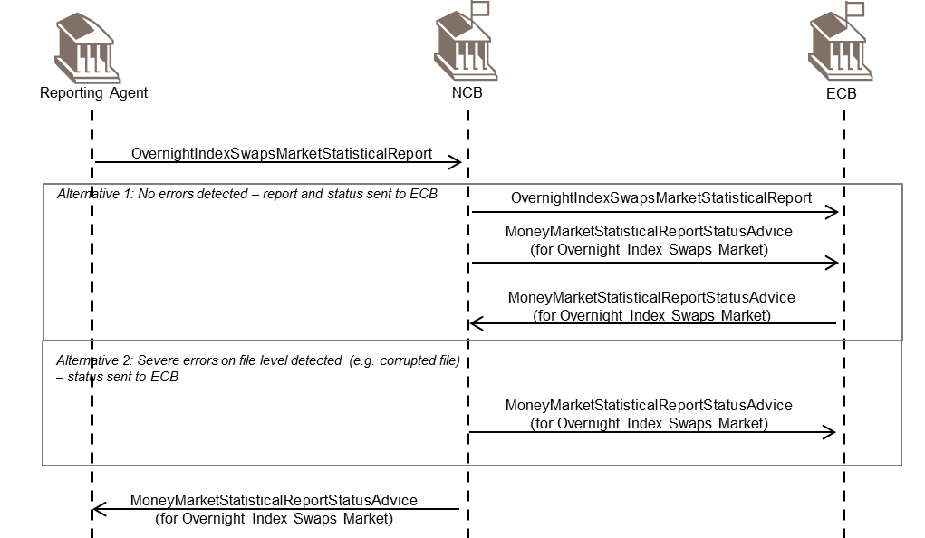

# Examples

This section describes business examples of the use of the various MessageDefinitions. Each example starts with a description of the example scenario followed by the actual MessageInstance.

## MMSR Secured Market Report - auth.012.001.02

Description

The following MessageInstance provides an example for the use of the report for the secured market segment for the case of a repurchase agreement conducted against general collateral with a nominal value of 10,000,000 and a collateral nominal amount of 12,000,000.

MessageInstance

<Document xmlns="urn:iso:std:iso:20022:tech:xsd:auth.012.001.02">

<MnyMktScrdMktSttstclRpt>

<RptHdr>

<RptgAgt>BEREPORTINGAGENT1234</RptgAgt>

<RefPrd>

<FrDtTm>2016-04-04T18:00:00+01:00</FrDtTm>

<ToDtTm>-2016-04-05T18:00:00+01:00</ToDtTm>

</RefPrd>

</RptHdr>

<ScrdMktRpt>

<Tx>

<RptdTxSts>NEWT</RptdTxSts>

<UnqTxIdr>UNI-TRN-ID-001a</UnqTxIdr>

<PrtryTxId>PRTY-TRN-ID-001a</PrtryTxId>

<CtrPtyPrtryTxId>CPTY-TRN-ID-001</CtrPtyPrtryTxId>

<CtrPtyId>

<LEI>BECOUNTERPARTY123456</LEI>

</CtrPtyId>

<TradDt>

<DtTm>2016-04-05T14:20:10+01:00</DtTm>

</TradDt>

<SttlmDt>2016-04-05</SttlmDt>

<MtrtyDt>2016-04-06</MtrtyDt>

<TxTp>BORR</TxTp>

<TxNmnlAmt Ccy="EUR">10000000</TxNmnlAmt>

<RateTp>FIXE</RateTp>

<DealRate>1.05</DealRate>

<Coll>

<Valtn>

<SnglColl>

<NmnlAmt

Ccy="EUR">12000000</NmnlAmt>

<ISIN>BE0000000001</ISIN>

</SnglColl>

</Valtn>

<Hrcut>16.6666</Hrcut>

<SpclCollInd>GENE</SpclCollInd>

</Coll>

</Tx>

</ScrdMktRpt>

</MnyMktScrdMktSttstclRpt>

</Document>

Description

The following MessageInstance provides an example for the use of the report for the secured market segment for the case of a securities lending transaction with a nominal value of 11,000,000 and a collateral nominal amount of 11,000,000.

MessageInstance

<Document xmlns="urn:iso:std:iso:20022:tech:xsd:auth.012.001.02">

<MnyMktScrdMktSttstclRpt>

<RptHdr>

<RptgAgt>BEREPORTINGAGENT1234</RptgAgt>

<RefPrd>

<FrDtTm>2016-04-04T18:00:00+01:00</FrDtTm>

<ToDtTm>-2016-04-05T18:00:00+01:00</ToDtTm>

</RefPrd>

</RptHdr>

<ScrdMktRpt>

<Tx>

<RptdTxSts>NEWT</RptdTxSts>

<UnqTxIdr>UNI-TRN-ID-001b</UnqTxIdr>

<PrtryTxId>PRTY-TRN-ID-001b</PrtryTxId>

<CtrPtyPrtryTxId>CPTY-TRN-ID-001</CtrPtyPrtryTxId>

<CtrPtyId>

<LEI>BECOUNTERPARTY123456</LEI>

</CtrPtyId>

<TradDt>

<DtTm>2016-04-05T14:20:10+01:00</DtTm>

</TradDt>

<SttlmDt>2016-04-05</SttlmDt>

<MtrtyDt>2016-04-06</MtrtyDt>

<TxTp>BORR</TxTp>

<TxNmnlAmt Ccy="EUR">11000000</TxNmnlAmt>

<RateTp>FIXE</RateTp>

<DealRate>1.05</DealRate>

<Coll>

<Valtn>

<SnglColl>

<NmnlAmt

Ccy="EUR">11000000</NmnlAmt>

<ISIN>BE0000000001</ISIN>

</SnglColl>

</Valtn>

<Hrcut>0</Hrcut>

<SpclCollInd>MRRP</SpclCollInd>

</Coll>

</Tx>

</ScrdMktRpt>

</MnyMktScrdMktSttstclRpt>

</Document>

Description

The following MessageInstance provides an example for the use of the report for the secured market segment for the case that no transaction is reported by the reporting agent (NOTX):

MessageInstance

<Document xmlns="urn:iso:std:iso:20022:tech:xsd:auth.012.001.02">

<MnyMktScrdMktSttstclRpt>

<RptHdr>

<RptgAgt>BEREPORTINGAGENT1234</RptgAgt>

<RefPrd>

<FrDtTm>2016-04-04T18:00:00+01:00</FrDtTm>

<ToDtTm>-2016-04-05T18:00:00+01:00</ToDtTm>

</RefPrd>

</RptHdr>

<ScrdMktRpt>

<DataSetAction>NOTX</DataSetAction>

</ScrdMktRpt>

</MnyMktScrdMktSttstclRpt>

</Document>

Description

The following MessageInstance provides an example for the use of the report for the secured market segment for the case that no report was received by the NCB from the reporting agent and the NCB reports to the ECB that the report is missing (NORA):

MessageInstance

<Document xmlns="urn:iso:std:iso:20022:tech:xsd:auth.012.001.02">

<MnyMktScrdMktSttstclRpt>

<RptHdr>

<RptgAgt>BEREPORTINGAGENT1234</RptgAgt>

<RefPrd>

<FrDtTm>2016-04-04T18:00:00+01:00</FrDtTm>

<ToDtTm>-2016-04-05T18:00:00+01:00</ToDtTm>

</RefPrd>

</RptHdr>

<ScrdMktRpt>

<DataSetAction>NORA</DataSetAction>

</ScrdMktRpt>

</MnyMktScrdMktSttstclRpt>

</Document>

## MMSR Unsecured Market Report - auth.013.001.02

Description

The following MessageInstance provides an example for the use of the report for the unsecured market segment for the case of an unsecured transaction with a nominal value of 10,000,000.

MessageInstance

<Document xmlns="urn:iso:std:iso:20022:tech:xsd:auth.013.001.02">

<MnyMktUscrdMktSttstclRpt>

<RptHdr>

<RptgAgt>BEREPORTINGAGENT1234</RptgAgt>

<RefPrd>

<FrDtTm>2016-04-04T18:00:00+01:00</FrDtTm>

<ToDtTm>-2016-04-05T18:00:00+01:00</ToDtTm>

</RefPrd>

</RptHdr>

<UscrdMktRpt>

<Tx>

<RptdTxSts>NEWT</RptdTxSts>

<NvtnSts>NOVA</NvtnSts>

<UnqTxIdr>UNI-TRN-ID-002</UnqTxIdr>

<PrtryTxId>PRTY-TRN-ID-002</PrtryTxId>

<RltdPrtryTxId>RELATED-PRTY-TRN-ID-102</RltdPrtryTxId>

<CtrPtyPrtryTxId>CPTY-TRN-ID-002</CtrPtyPrtryTxId>

<CtrPtyId>

<LEI>BECOUNTERPARTY123456</LEI>

</CtrPtyId>

<TradDt>

<DtTm>2016-04-05T16:33:10+01:00</DtTm>

</TradDt>

<SttlmDt>2016-04-11</SttlmDt>

<MtrtyDt>2016-04-12</MtrtyDt>

<TxTp>LEND</TxTp>

<InstrmTp>DPST</InstrmTp>

<TxNmnlAmt Ccy="EUR">100000000</TxNmnlAmt>

<DealPric>100</DealPric>

<RateTp>FIXE</RateTp>

<DealRate>-0.05</DealRate>

</Tx>

</UscrdMktRpt>

</MnyMktUscrdMktSttstclRpt>

</Document>

## MMSR Foreign Exchange Swaps Report - auth.014.001.02

Description

The following MessageInstance provides an example for the use of the report for the FX swap segment for the case of a transaction EUR versus JPY.

MessageInstance

<Document xmlns="urn:iso:std:iso:20022:tech:xsd:auth.014.001.02">

<MnyMktFXSwpsSttstclRpt>

<RptHdr>

<RptgAgt>BEREPORTINGAGENT1234</RptgAgt>

<RefPrd>

<FrDtTm>2016-04-04T18:00:00+01:00</FrDtTm>

<ToDtTm>-2016-04-05T18:00:00+01:00</ToDtTm>

</RefPrd>

</RptHdr>

<FXSwpsRpt>

<Tx>

<RptdTxSts>NEWT</RptdTxSts>

<UnqTxIdr>UNI-TRN-ID-003</UnqTxIdr>

<PrtryTxId>PRTY-TRN-ID-003</PrtryTxId>

<CtrPtyId>

<SctrAndLctn>

<Sctr>S11</Sctr>

<Lctn>GB</Lctn>

</SctrAndLctn>

</CtrPtyId>

<TradDt>

<DtTm>2016-04-05T13:27:10+01:00</DtTm>

</TradDt>

<SpotValDt>2016-04-12</SpotValDt>

<MtrtyDt>2016-05-09</MtrtyDt>

<TxTp>SELL</TxTp>

<TxNmnlAmt Ccy="EUR">35000000</TxNmnlAmt>

<FX>

<FrgnCcy>JPY</FrgnCcy>

<XchgSpotRate>141</XchgSpotRate>

<XchgFwdPt>-4.25</XchgFwdPt>

</FX>

</Tx>

</FXSwpsRpt>

</MnyMktFXSwpsSttstclRpt>

</Document>

## MMSR Overnight Index Swaps Report - auth.015.001.02

Description

The following MessageInstance provides an example for the use of the report for the OIS segment for the case of paid fixed rate and a received variable rate. The reporting of the NameAndLocation element is not applicable for the MMSR since for this data collection either the Counterparty LEI or the Counterparty SectorAndLocation have to be reported.

MessageInstance

<Document xmlns="urn:iso:std:iso:20022:tech:xsd:auth.015.001.02">

<MnyMktOvrnghtIndxSwpsSttstclRpt>

<RptHdr>

<RptgAgt>BEREPORTINGAGENT1234</RptgAgt>

<RefPrd>

<FrDtTm>2016-04-04T18:00:00+01:00</FrDtTm>

<ToDtTm>-2016-04-05T18:00:00+01:00</ToDtTm>

</RefPrd>

</RptHdr>

<OvrnghtIndxSwpsRpt>

<Tx>

<RptdTxSts>NEWT</RptdTxSts>

<UnqTxIdr>UNI-TRN-ID-004</UnqTxIdr>

<PrtryTxId>PRTY-TRN-ID-004</PrtryTxId>

<CtrPtyId>

<NmAndLctn>

<Nm>ING</Nm>

<Lctn>NL</Lctn>

</NmAndLctn>

</CtrPtyId>

<TradDt>

<DtTm>2016-04-05T16:53:40+01:00</DtTm>

</TradDt>

<StartDt>2016-04-06</StartDt>

<MtrtyDt>2016-04-13</MtrtyDt>

<FxdIntrstRate>-0.01</FxdIntrstRate>

<TxTp>PAID</TxTp>

<TxNmnlAmt Ccy="EUR">10000000</TxNmnlAmt>

</Tx>

</OvrnghtIndxSwpsRpt>

</MnyMktOvrnghtIndxSwpsSttstclRpt>

</Document>

# Revision Record

|  |  |  |  |  |
| --- | --- | --- | --- | --- |
| **Revision** | **Date** | **Author** | **Description** | **Sections affected** |
| 0.1 | 10 July 2015 | ECB / SWIFT | First version for submission to RA | All |
| 0.2 | 29 July 2015 | ECB/SWIFT | Updates in response to ISO 20022 RA comments following the quality review | TOC and section 6 |
| 1.0 | 13 August 2015 | ISO 20022 RA | Final editing before submission to SEG | Sections 2, 3 and 7 |
| 2.0 | 27 January 2016 | ISO 20022 RA | Final editing before publication | All |
| 3.0 | 23 February 2017 | ECB/ SWIFT | Updates following approval of CR 0644 | Section 7 |
| 4.0 | 23 February 2017 | ISO 20022 RA | Editing before submission to SEG | All |
| 5.0 | 22 May 2017 | ECB | Update based on comments from Evaluation Team | Section 7 |
| 6.0 | 29 May 2017 | ISO 20022 RA | Final version before publication | All |

**Disclaimer**:

Although the Registration Authority has used all reasonable efforts to ensure accuracy of the contents of the iso20022.org website and the information published thereon, the Registration Authority assumes no liability whatsoever for any inadvertent errors or omissions that may appear thereon. Moreover, the information is provided on an "as is" basis. The Registration Authority disclaims all warranties and conditions, either express or implied, including but not limited to implied warranties of merchantability, title, non-infringement and fitness for a particular purpose.

The Registration Authority shall not be liable for any direct, indirect, special or consequential damages arising out of the use of the information published on the iso20022.org website, even if the Registration Authority has been advised of the possibility of such damages.

**Intellectual Property Rights**:

The ISO 20022 MessageDefinitions described in this document were contributed by the ECB. The ISO 20022 IPR policy is available at www.ISO20022.org > About ISO 20022 > Intellectual Property Rights.

1. The reporting agents will be euro area resident monetary financial institutions with the exception of money market funds and central banks.
2. The according Regulation (EU) No 1333/2014 of the European Central Bank can be accessed under: <https://www.ecb.europa.eu/ecb/legal/pdf/oj_jol_2014_359_r_0006_en_txt.pdf>
3. The ECB has defined a subset of fields to be used in the BAH to fully support the reporting requirements as defined in the MMSR specifications.